LOGIN:

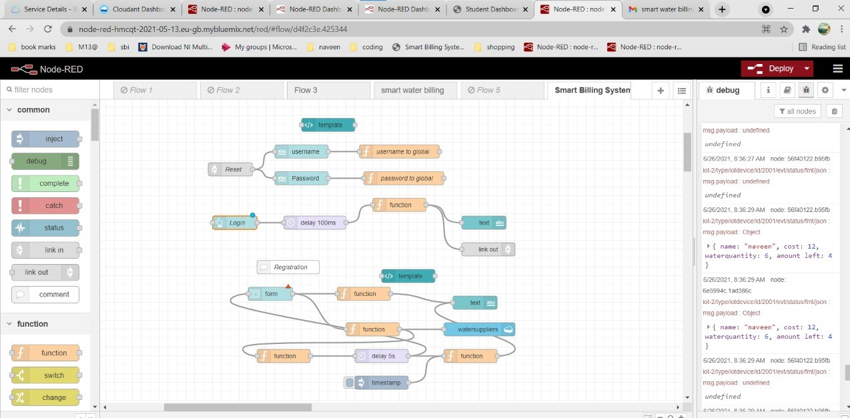

LOGIN FORM:

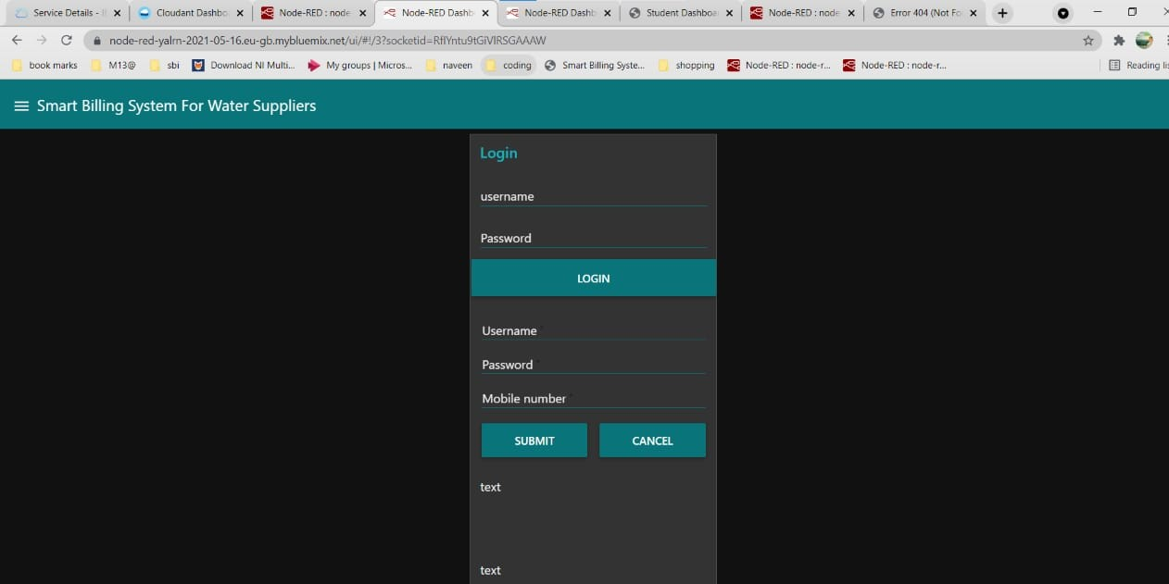

DISPLAYING MESSAGES OF COST,AMOUNT DETECTION,AMOUNT LEFT, NAME:

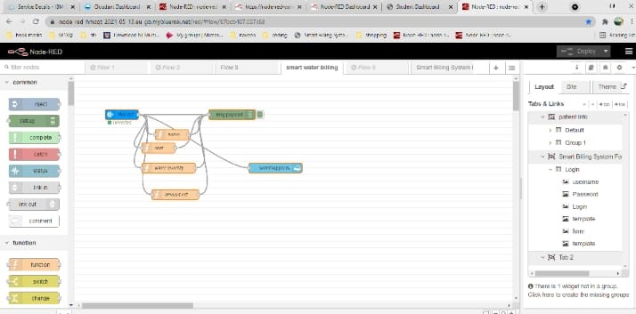

OUTPUTS:

